**Activity: Improving accessibility with tooltips**

**Introduction**

Congratulations on completing another activity successfully. In the previous activity, *Creating an accessible report*, you improved the accessibility of an AdventureWorks sales report using formatting, themes, and design best practices. Although you have improved the report from an accessibility perspective, you can improve it even further using tooltips.

**Instructions: Improving accessibility with tooltips**

Your task now is to refine the accessibility of the report by integrating tooltips. These tooltips should provide more detailed information about each data point when a user hovers over it. This task aims to make the data more comprehensible without sacrificing the clean visual presentation of the report.

**Step 1: Open the previous activity file in Power BI Desktop.**

1. Select **File menu**, followed by **Open Report**.
2. Select the file you created for the previous activity, *Creating an accessible report*.

**Step 2: Display order quantity in the tooltip for each region in the line chart.**

1. Select the line chart and drag the **Order Quantity** field into the **Tooltips** well.
2. Hover over any data point on the line chart to ensure that the newly added order quantity data is visible in the tooltip, as demonstrated in the screenshot below.

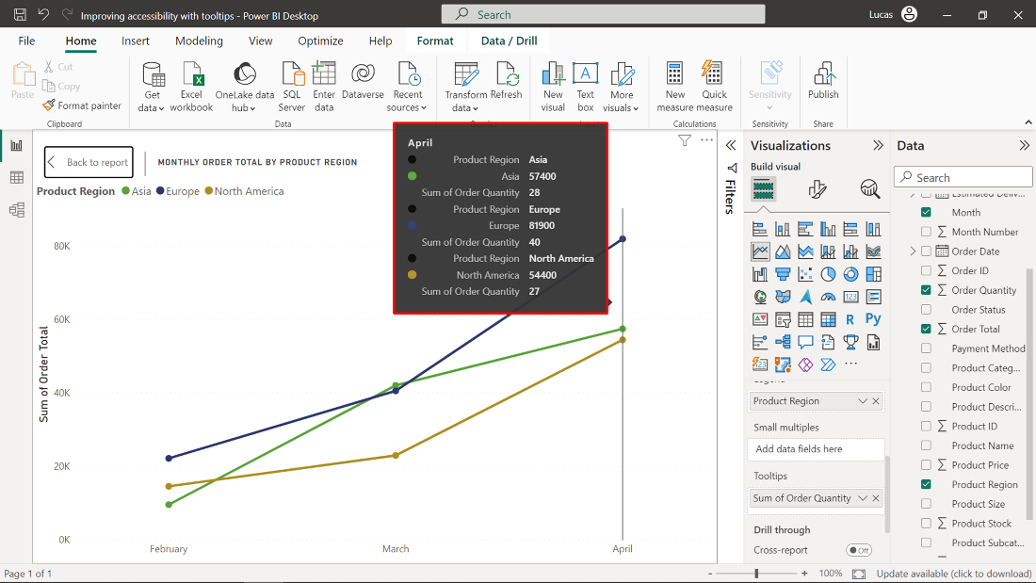

**Step 3: Display average product price and total order quantity in the clustered column chart.**

1. Select the clustered column chart on the bottom left corner and drag **Order Total** field into the **Tooltips** well.
2. Drag the **Product Price** field to the **Tooltips** well, select the **arrow** icon beside this field, and select the **Average** aggregate function instead of **Sum**.
3. Hover over any data point on the clustered column chart to confirm that these newly added fields are appearing in the tooltip, as demonstrated in the screenshot below.

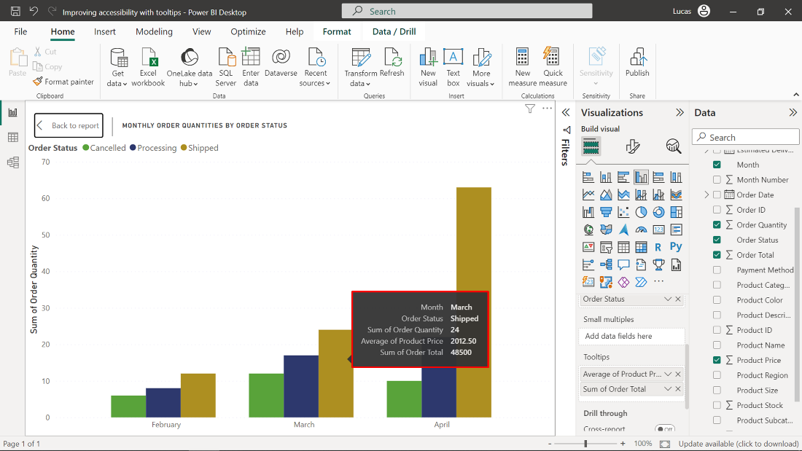

**Step 4: Display total sales in the stacked bar chart**

1. Select the stacked bar chart on the bottom right corner and drag **Order Total** field into the **Tooltips** well.
2. Hover over any data point on the stacked bar chart to confirm that the newly added field is appearing in the tooltip, as demonstrated in the screenshot below.

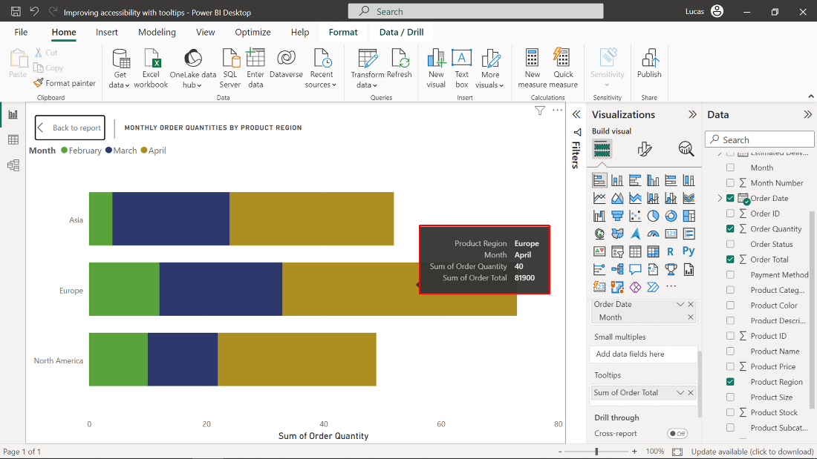

**Task 5: Save the report for future use.**

* Once you have made all the necessary changes, save the report by opening **File menu** and selecting **Save**.

**Conclusion**

In this activity, you added an additional interactive dimension to your report by including custom tooltips, enhancing overall accessibility. These tooltips will empower all users to more easily understand data points in the different charts, all without cluttering your report’s presentation. Combined with the other formatting and design best practices you learned about in this lesson, you are now better equipped to enable inclusive data exploration and decision-making.